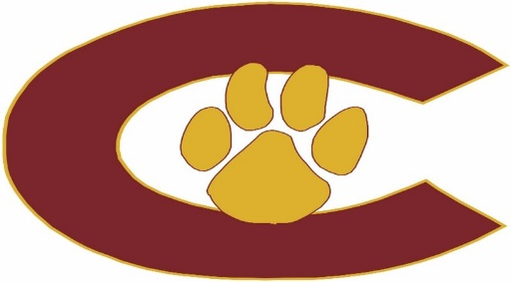

2025-26 SWIMMING AND DIVING

DATE OPPONENT SITE H/A TIME JV/VAR
8/4-8/8 Practice Begins Clearwater HS 2:30-4:00 pm
8/11 Regular Practice Clearwater HS 2:30-5:00 pm
8/15 Garnet & Gold Clearwater HS 2:30-5:30 pm
Intrasquad Meet
8/20+ Dunedin Dunedin High A 6:30 pm
8/28+ Seminole Clearwater HS H 6:30 pm
9/4 St Petersburg Clearwater HS H 6:30 pm
9/11 East Lake Clearwater HS H 6:30 pm
9/20 PCACs SW Rec Center 8:00am
9/25* Palm Harbor Clearwater HS H 6:30 pm
10/1 Osceola Seminole HS A 6:30 pm
10/4 Battle of the Bay N Shore Aq Center 7:00 am
10/8+ Clearwater Clearwater HS A 6:30 pm

10/25 District Tournament TBD TBD
11/1 Regional Tournament TBD TBD
11/7 State Tournament TBD

TBD Banquet

*Senior Night
+District 2A R3 D8 (Blake, Boca Ciega, Chamberlain, Clearwater, Cside, Dunedin, Gibbs, Jefferson, Robinson, Seminole)

Head Coach: Mark Kantzler kantzlerm@pcsb.org
Principal: Taylor Henderson – hendersont@pcsb.org
Athletic Director: Erin Overall – overalle@pcsb.org
Athletic Coordinator: Tony Klemmer – klemmera@pcsb.org
Athletic Trainer: Tillery Greco – tillery.greco@baycare.org
Assistant Principals: Brad Bernstein and Robert Murphy

Last update: 7/16/2025

